
COMSATS UNIVERSITY ISLAMABAD
Department of Computer Science

Assignment # 2
CSC417 - E-Commerce & Digital Marketing

TRENDLY
Catch the trend before it's everywhere.

Full Name | Muhammad Abdullah
Registration No. | FA24-BSE-042
Course | CSC417 - E-Commerce & Digital Marketing
Instructor | Sir Omer Vikas
Semester | Spring 2026
Due Date | March 24, 2026

Question 1: The Eight Most Important Factors in Successful E-Commerce Site Design
The following table evaluates 10 real-world e-commerce websites including direct and indirect competitors of Trendly against Table 4.11 (Chapter 4, Laudon & Traver, 2023). Direct competitors are those selling trending fashion/lifestyle/tech products; indirect competitors are broader marketplaces.
Legend: ✓ Applies well | ~ Partial | ✗ Fails.

Website | Functionality | Informational | Ease of Use | Redundant Nav | Ease of Purchase | Multi-Browser | Simple Graphics | Legible Text
Daraz.pk (Direct Competitor) | ✓ Fast, mobile-optimised | ✓ Seller info & product specs | ~ OK but cluttered | ✓ Breadcrumbs + sidebar | ✓ 1-tap Buy Now | ✓ All browsers | ~ Heavy banner ads | ✓ Clear fonts
Amazon.com (Indirect) | ✓ Excellent speed | ✓ Rich descriptions & reviews | ✓ Intuitive layout | ✓ Multi-path navigation | ✓ 1-click purchase | ✓ All browsers | ~ Busy homepage | ✓ Highly readable
AliExpress (Indirect) | ~ Moderate load time | ✓ Supplier & specs info | ~ Complex for new users | ✓ Filters + categories | ~ Multi-step checkout | ✓ All major browsers | ✗ Cluttered graphics | ✓ Legible text
Shein.com (Direct) | ✓ Fast CDN delivery | ✓ Size guides, reviews | ✓ Clean trendy UI | ✓ Category + search | ✓ Quick checkout | ✓ All browsers | ✓ Minimal, on-brand | ✓ Good contrast
Zalando.pk (Indirect) | ✓ Reliable performance | ✓ Brand/material details | ✓ Easy filtering | ✓ Redundant nav paths | ✓ Express checkout | ✓ All browsers | ✓ Clean editorial style | ✓ Legible text
Telemart.pk (Direct) | ✓ Quick loading | ✓ Specs & warranty shown | ✓ Clear layout | ✓ Category + search nav | ✓ Easy checkout | ✓ All browsers | ✓ Product-focused | ✓ Good contrast
Homeshopping.pk (Direct) | ~ Slow on mobile | ✓ Good descriptions | ~ Moderate | ✓ Multiple nav paths | ✓ Simple purchase flow | ~ Minor issues | ✓ Simple graphics | ✓ Readable
Shophive.com (Indirect) | ✓ Good performance | ✓ Tech specs clear | ✓ Clean navigation | ✓ Menu + search | ✓ Easy checkout | ✓ All browsers | ✓ Product-focused | ✓ Good contrast
OLX Pakistan (Indirect) | ✓ Fast, lightweight | ✓ Seller contact info | ✓ Simple UI | ✓ Category + search | ~ Contact-only, no cart | ✓ All browsers | ✓ Minimal UI | ✓ Legible
Flipkart.com (Indirect) | ✓ Fast & reliable | ✓ Ratings & full specs | ✓ Easy to use | ✓ Breadcrumbs + filters | ✓ Quick buy option | ✓ All browsers | ✓ Clean design | ✓ Clear typography

Analysis Summary
Global platforms (Amazon, Flipkart) score highest across all eight factors due to mature UX investment. Pakistan-specific platforms like Daraz.pk and Telemart.pk perform well but suffer from cluttered homepages. AliExpress fails noticeably on simple graphics. OLX Pakistan is highly functional but lacks a direct purchase flow. Trendly aims to outperform local competitors by addressing the most common failures: clean minimal graphics, fast checkout, and consistent cross-browser rendering.

Question 2: E-Commerce Store UI/UX Mockup & Architecture Design
This section translates the Trendly Business Plan (Assignment 1) into a visual e-commerce architecture. Trendly is a B2C e-tailer focused on trending fashion, lifestyle, and tech products targeting 18-30 year-old social-media-active consumers.

Part A: Information Architecture

A.1 - Sitemap
The sitemap maps all pages within Trendly's platform, organised around the consumer purchase journey:

HOME PAGE
├── Shop by category
│ └── Fashion | Lifestyle | Tech gadgets | Accessories | Sale
├── Product listing page (PLP)
│ └── Product detail page (PDP)
├── Cart page
│ └── Checkout page → Order confirmation
├── User account
│ └── Login / Register / Orders / Wishlist
├── About us
├── Contact us
└── Help & FAQ

A.2 - Navigation Hierarchy Structure
Trendly uses a three-tier navigation model to ensure redundant navigation and ease of use:

Tier | Type | Elements
Tier 1 | Global Navigation (Sticky Top Bar) | Logo, Category Menu, Search Bar, Cart Icon, Account
Tier 2 | Contextual Navigation (Breadcrumbs + Filters) | Home › Category › Product Price/Brand/Rating filters
Tier 3 | Footer Navigation | About, Contact, FAQ, Returns, Social Media Links

A.3 - Product Category Tree

Trendly - Product Category Tree
Fashion | Lifestyle | Tech Gadgets | Accessories
Tops, Bottoms Dresses, Hoodies Sneakers | Home Decor Candles, Planters Wellness Items | Earphones, Cables Phone Cases Smart Gadgets | Bags, Wallets Sunglasses, Caps Jewelry

Part B: Mockups
The following wireframe-style mockups illustrate the layout of Trendly's five core pages. Brand colours: Teal (#0D6E6E) and Gold (#D4A017) on clean white backgrounds. Design philosophy: minimal, trend-forward, mobile-first.

Mockup 1 Homepage

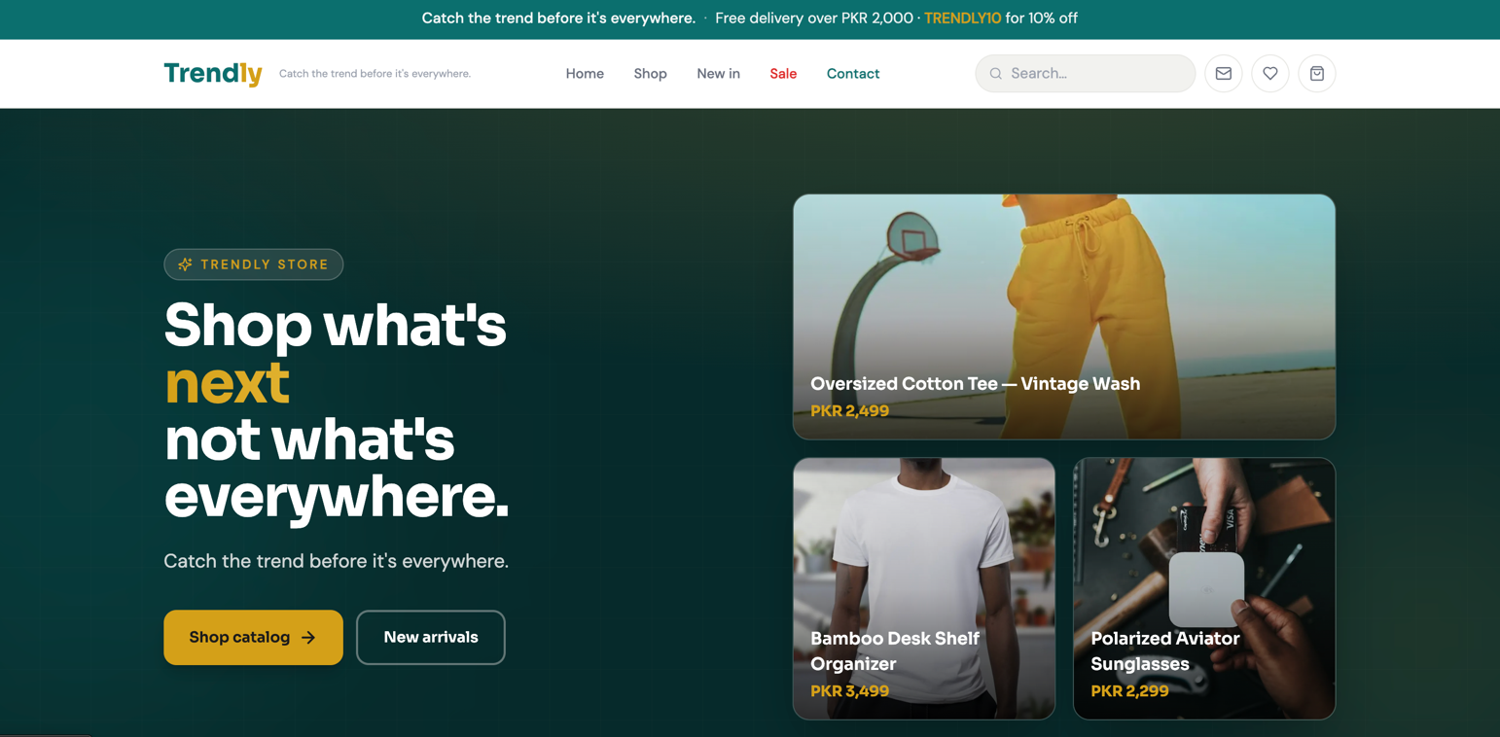
Homepage Rationale: Sticky navbar ensures redundant navigation. Hero banner drives urgency. Category pills provide instant wayfinding (ease of use). Trust bar addresses the top purchase barriers for young Pakistani shoppers.

Mockup 2 - Product Listing Page (PLP)
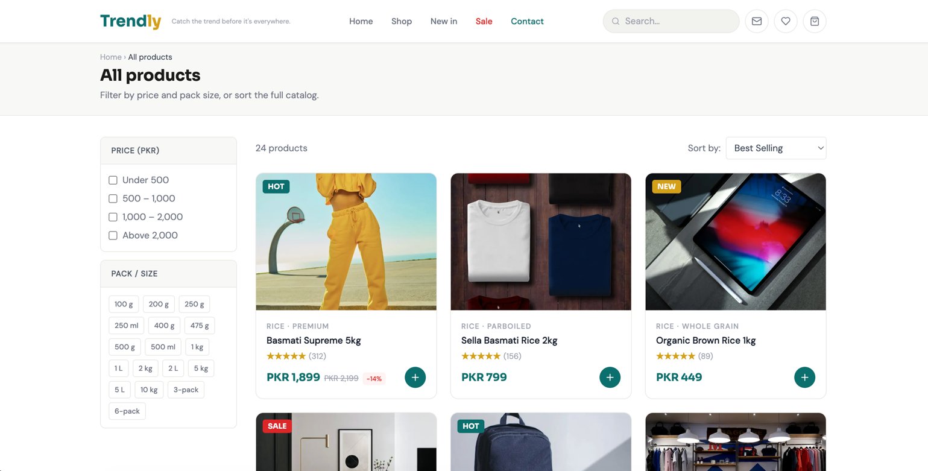
PLP Rationale: Left-side filters allow redundant navigation paths. Sort options empower user control. Clean card grid with consistent 'Add to Cart' CTAs ensures ease of purchase. Breadcrumbs confirm location within the store.

Mockup 3 - Product Detail Page (PDP)
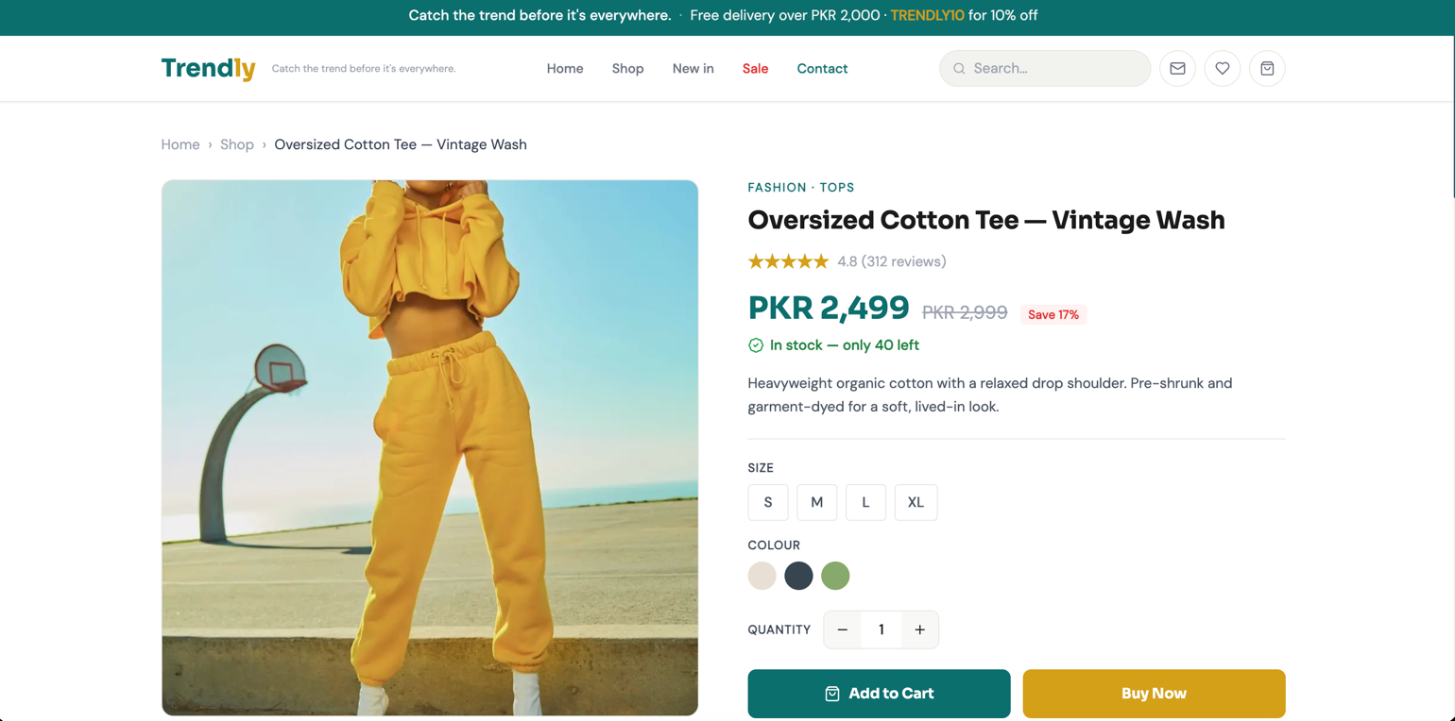
PDP Rationale: Dual CTAs (Add to Cart + Buy Now) serve both browsers and impulse buyers. Size and colour selectors follow simple foolproof navigation. Review count + savings badge reduce purchase anxiety. Trust chips (secure pay, returns, authentic) build confidence.

Mockup 4 - Cart Page
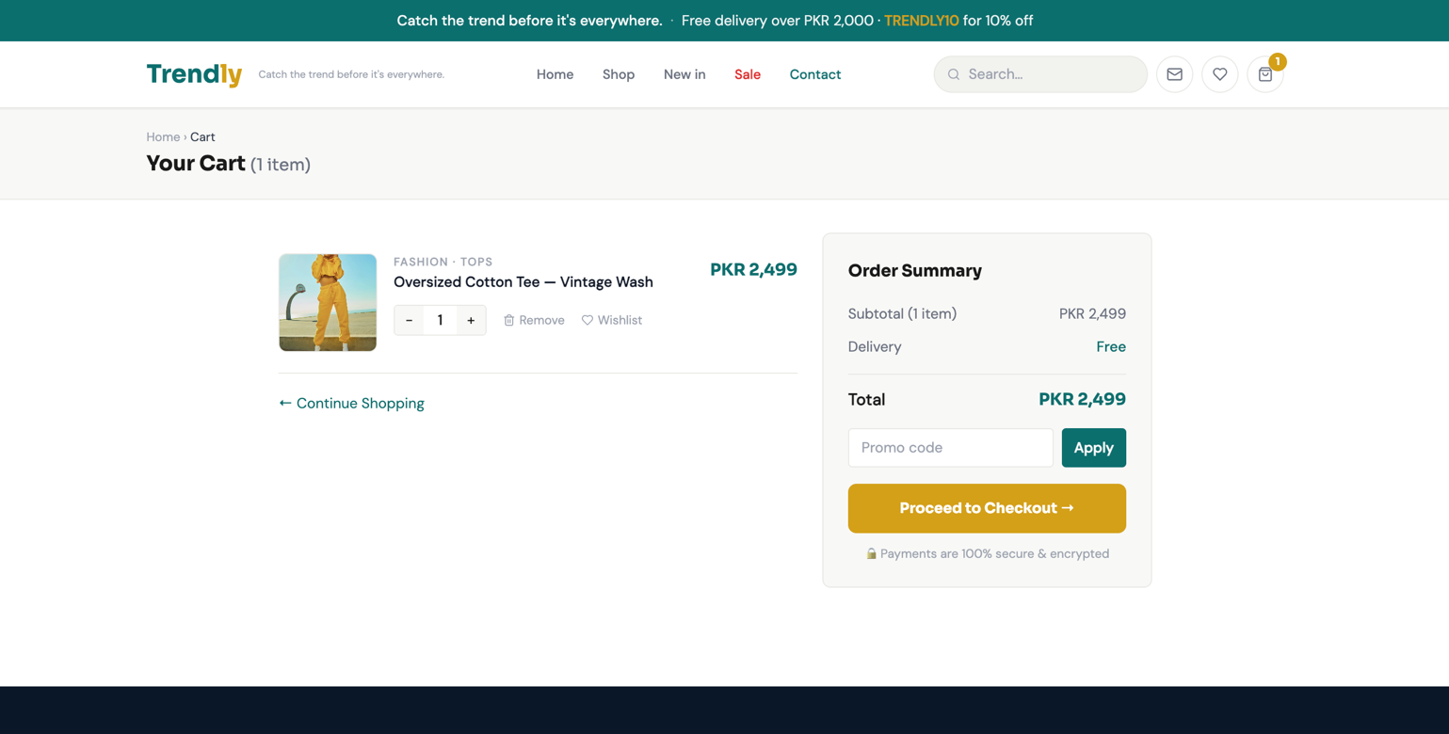
Cart Rationale: Split layout shows items and summary simultaneously. Persistent checkout CTA ensures ease of purchase. Promo code entry adds value without clutter. Remove and wishlist actions are visible but non-disruptive.

Mockup 5 - Checkout Page
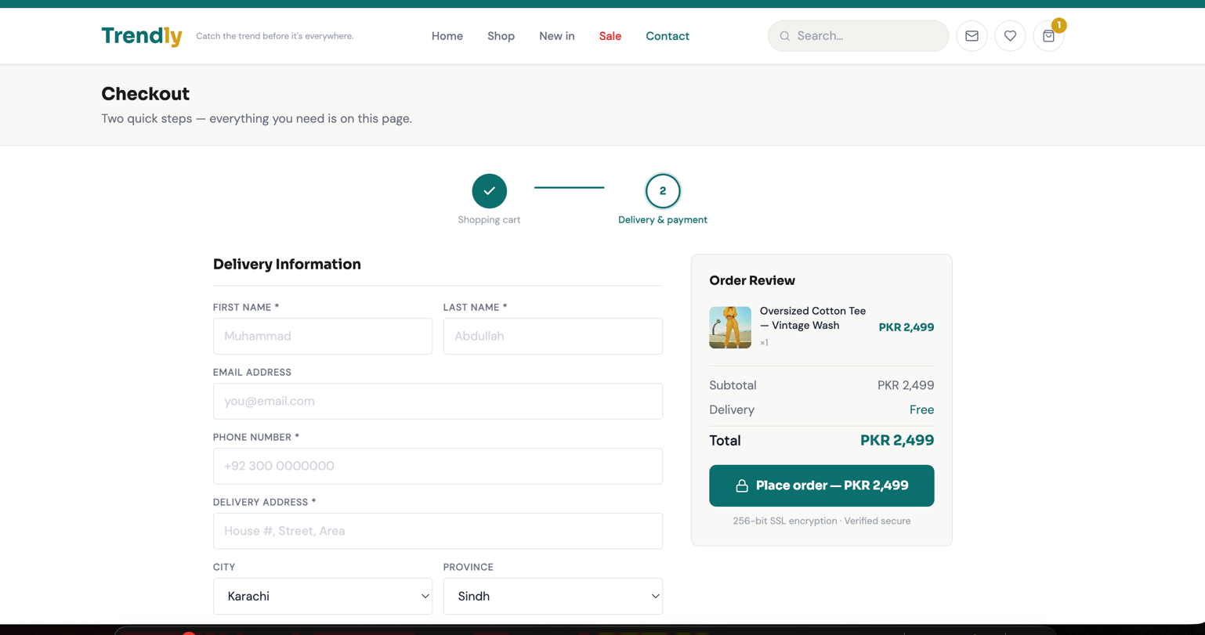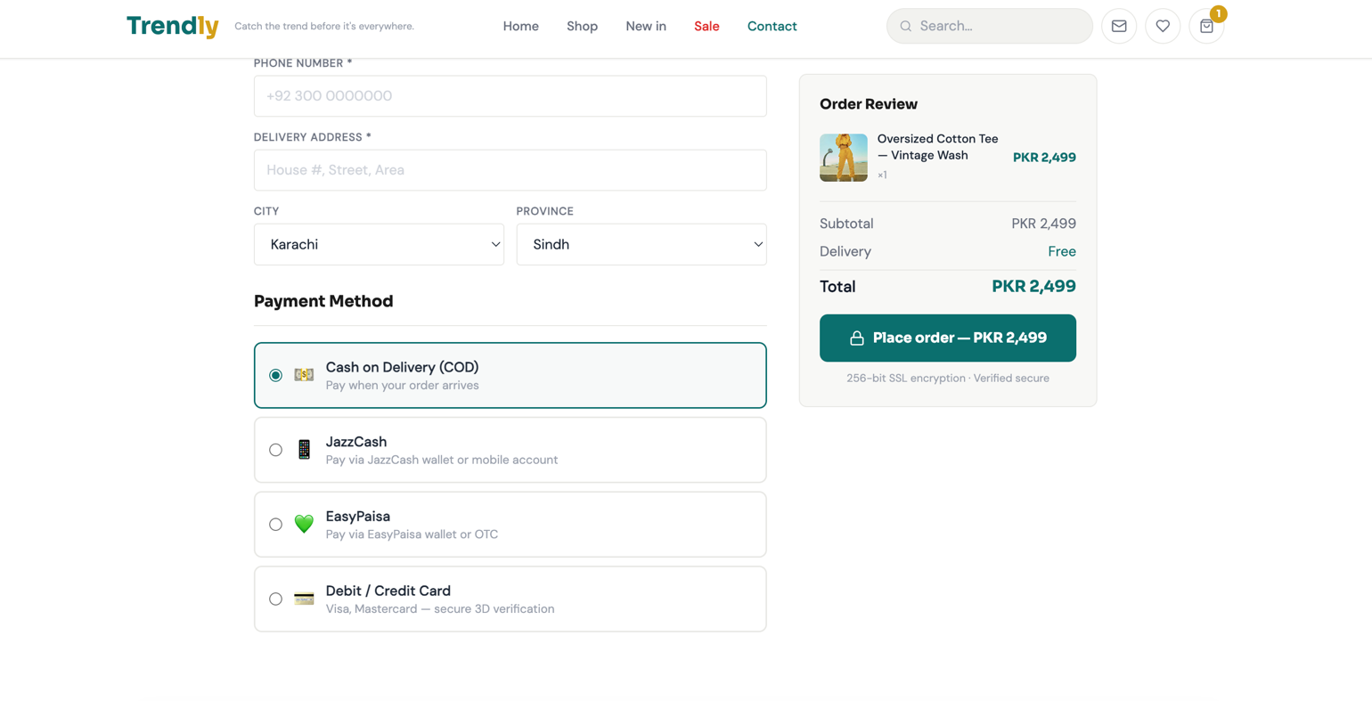
Checkout Rationale: 4-step progress bar sets clear expectations and reduces abandonment. Pre-selected COD matches Pakistan's most common payment method. Multiple payment options cater to all users. Order review panel eliminates the need to navigate back. Security badges appear near the Place Order button where anxiety peaks.

Written Explanation

Design Philosophy
Trendly's UI/UX is built around three core principles: minimal aesthetics, frictionless purchase, and trust. As a brand targeting 18-30 year-old social-media users, the design avoids visual clutter and uses bold teal and gold tones that feel modern and energetic distinct from generic marketplace aesthetics.

Information Architecture
- The sitemap follows a linear purchase journey: Discovery (Home › Categories) → Evaluation (PLP › PDP) → Transaction (Cart › Checkout › Confirmation). This reduces cognitive load and aligns with how trend-focused shoppers browse.
- Three-tier navigation (global top bar, breadcrumbs, footer) ensures users can always orient themselves and find alternative paths to any page, directly addressing the redundant navigation factor.
- The category tree (Fashion, Lifestyle, Tech, Accessories) maps directly to Trendly's curated product offering and supports efficient browsing without overwhelming the user.

Mockup Design Decisions
- Homepage: Hero banner communicates brand identity instantly. Category pills provide one-click access to all departments. The trust bar (free delivery, returns, secure pay, 24/7 support) directly tackles the top barriers to first purchases by young Pakistani consumers.
- Product Listing Page: Left-sidebar filters follow established conventions. Grid cards with consistent image areas, star ratings, prices, and Add to Cart CTAs make scanning and purchasing effortless. Pagination prevents performance degradation on mobile.
- Product Detail Page: Dual CTAs (Add to Cart + Buy Now) serve both considered and impulse buyers. Size/colour selectors use simple radio-style tabs. Review count, savings badge, and stock alert reduce purchase hesitation.
- Cart Page: The two-column layout (items on left, summary on right) lets users review everything without scrolling. Persistent Checkout CTA stays visible. Promo code input is accessible but not prominent, keeping the focus on completing the purchase.
- Checkout Page: The 4-step progress indicator sets clear expectations. COD is pre-selected because it is Pakistan's dominant payment method for new customers. Multiple digital payment options (JazzCash, EasyPaisa, Card) are available without overwhelming the screen. The order review panel eliminates the need to go back and reduces abandonment.

Alignment with the Eight Design Factors
Every mockup adheres to all eight factors: pages are structured for fast load (functionality); product info, seller details, and policies are surfaced at the correct stage (informational); navigation is consistent and intuitive (ease of use + redundant navigation); checkout is achievable in two to three clicks from any product page (ease of purchase); all components use standard HTML/CSS-compatible elements (multi-browser); product images are the only visuals, with no auto-playing media (simple graphics); and Trendly's teal/white/grey palette with legible sans-serif typography ensures all text is clear and scannable (legible text).

